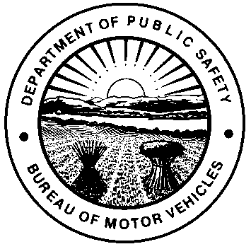 |  | OHIO DEPARTMENT OF PUBLIC SAFETY  BUREAU OF MOTOR VEHICLES  TRANSFER ON DEATH BENEFICIARY  DESIGNATION / REMOVAL AFFIDAVIT  Ohio Revised Code (R.C.) section 2131.13
This form is used to add and/or remove a transfer on death beneficiary. Please only check one box for the action you are taking.
DESIGNATION |  |  |  |  |  | REMOVAL
An individual with sole ownership or two persons who have established joint ownership with right of survivorship of a motor vehicle, watercraft, or outboard motor, all-purpose vehicle, off-highway motorcycle may make an application for a Certificate of Title to designate/remove one or more beneficiaries of the property.
I / We, |  |  |  |  | being the sole owner or the joint owners with right of survivorship of the
 | (PRINTED NAME)
vehicle, watercraft, outboard motor, all-purpose vehicle, or off-highway motorcycle described in this form, do designate/remove the
following beneficiaries for this property:
BENEFICIARY FULL LEGAL NAME |  |  |  | SSN |  |  |  |  | DATE OF BIRTH
BENEFICIARY FULL LEGAL NAME |  |  |  | SSN |  |  |  |  | DATE OF BIRTH
BENEFICIARY FULL LEGAL NAME |  |  |  | SSN |  |  |  |  | DATE OF BIRTH
VIN / HIN / MIN |  |  |  |  |  |  | YEAR
MAKE |  |  | MODEL |  |  |  | BODY TYPE
APPLICANT(S) / OWNER(S) SIGNATURE  X |  |  |  |  |  |  |  | DATE
Notary:
Sworn to and subscribed in my presence this day of , 20 in County,
State of .
(Notary Seal)
X My commission expires
Signature of Notary Public or other Authorized Officer by law

NOTE: A motor vehicle dealer licensed in accordance with 4517 of the R.C., who is the owner or purchaser of the motor vehicle, is not required to have this document notarized under section 4505.063 of the R.C.

